Calapooia River Invasive Plant Assessment

Final Report

February 2013

Carex Working Group
1377 NW Alta Vista Drive
Corvallis, OR 97330

Submitted to:
Calapooia Watershed Council
P.O. Box 844
Brownsville, OR 97327

Introduction

Calapooia Watershed Council contracted with Carex Working Group (CWG) to develop and carry out an invasive plant assessment along two reaches of the Calapooia River near Brownsville, Oregon. The purpose of the project was to assess the riparian habitat quality and document invasive plant populations along the two reaches. Results from the project will be used to develop management priorities with public and private landowners, managers, and other stakeholders.

The project had three components:
- Conduct field surveys to determine location and extent of invasive species, particularly populations that are still small enough to control (“new invaders”); to locate areas of high quality habitat and areas at greatest risk; and to identify areas where containment of invasive plants is a priority.
- Provide recommendations for weed control and habitat protection.
- Shapefiles with mapping of weed populations and high quality habitats.
Methods
Field surveys along the Calapooia River were conducted during September 2012. Botanists surveyed two reaches (Figure 1) for populations of invasive plants. Only properties for which owner permission had been obtained were surveyed. Target invasive plant species of interest were determined from a list of invasive plants provided by Calapooia Watershed Council (Table 1). Because Himalayan blackberry (Rubus bifrons) and reed canarygrass (Phalaris arundinacea) are ubiquitous in both reaches these species were not mapped.
High quality habitats were also mapped. High quality habitats generally were dominated by native species, with high native species and structural diversity, and low levels of invasive species. Invasive species and high quality and priority habitats were mapped using a hand-held GPS to obtain UTM coordinates with an estimated patch radius, or as a hand-drawn polygon on a map overlay. Mapping was imported into a GIS shapefile and GIS was used to generate the hardcopy mapping included with this report. Weed population and habitat data and mapping are being submitted in computer files to the Calapooia Watershed Council with this report.

Figure 1. Calapooia weed assessment survey areas (Calapooia Watershed Council 2012).

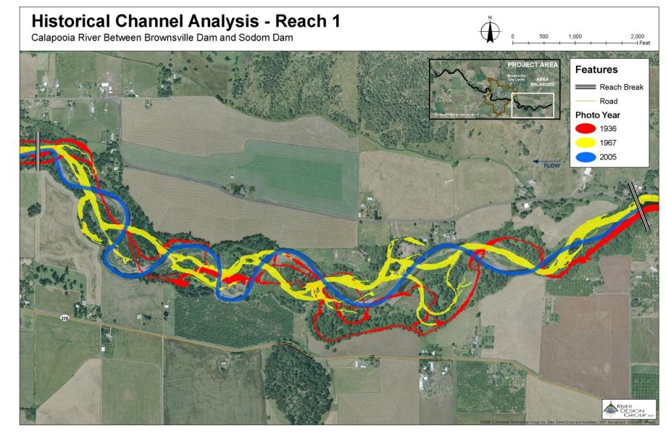

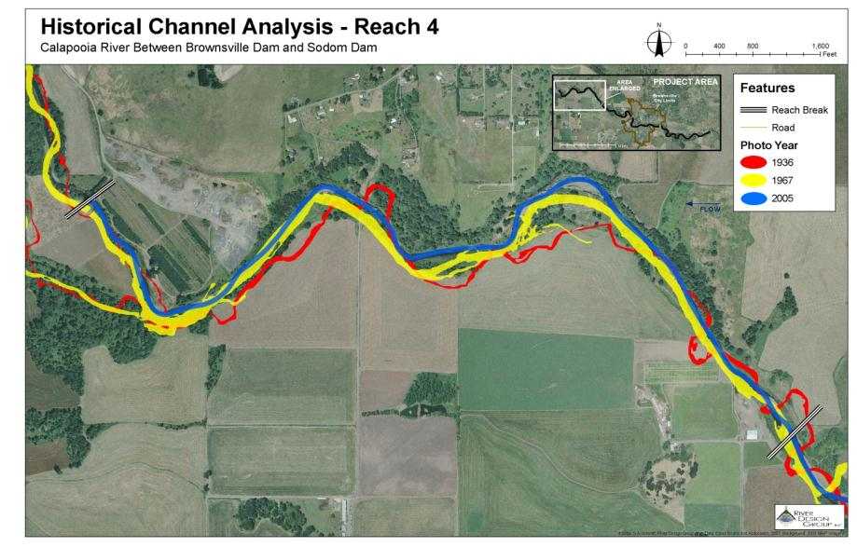
Results
Himalayan blackberry and reed canarygrass were ubiquitous in both reaches, often forming dense monocultural thicket and stands. Because these species are so abundant within the project area, no attempt was made to map them. Cover of these species was reduced somewhat in areas of dense tree cover (e.g., cottonwood, ash, and bigleaf maple) or native shrub cover (e.g. willows). Large impenetrable thickets of Himalayan blackberry tended to form at edges and where forested habitat was fragmented. Reed canarygrass was primarily observed on lower, wetter terraces adjacent to the river. Dense willow cover and seasonal flooding appeared to reduce or prevent establishment of reed canarygrass, along with most other herbaceous plants.
The field surveys documented 22 other invasive species in 149 populations (Table 2 and Figures 2 and 3). English and Atlantic ivy (Hedera helix and H. hibernica), were common in much of the project area, forming dense patches in the herbaceous layer and climbing into the crowns of overstory trees. Small, scattered populations of false brome (Brachypodium sylvaticum) were observed in forest understories. Several small patches of Japanese knotweed (Fallopia japonica) were observed within the project area, most of which were located near the seasonal high water mark of the river. Scotch broom (Cytisus scoparius) is common in open areas used as landings for farm equipment or for gravel extraction
Black and English walnut (Juglans nigra and J. regia), black locust (Robinia pseudoacacia), English holly (Ilex aquifolium), sweet cherry (Prunus avium), and English hawthorn (Crataegus monogyna) were observed in riparian areas along the river. Both walnut species and black locust likely have seeded in from trees planted nearby or have been transported by birds. Sweet cherry, English holly, and English hawthorn likely originated from seed transported by birds. Sweet cherry was common both as solitary trees and in patches in open and closed canopies. English hawthorn is common in upland areas dominated by Oregon white oak (Quercus garryana).
There are a few locations in the project area where beaver activity and river flow dynamics have created slack water and marshy areas that support aquatic plants. These areas are important off-channel habitat for native aquatic and emergent plants, fish and wildlife. Two invasive aquatic plants, watermilfoil (Myriophyllum sp.) and floating primrose-willow (Ludwigia peploides), were observed in small patches along the river’s edge. Large gravel bars are common throughout both reaches. Scattered populations of purple loosestrife (Lythrum salicaria), Japanese knotweed, and tansy ragwort (Senecio jacobaea) were found on gravel bars among patches of willows.
We mapped just one patch of high quality habitat in the upper reach on the Barron and Holbrook properties, a forested area with an overstory of bigleaf maple, a shrub layer of snowberry (Symphoricarpos albus) and a relatively diverse layer of native herbs (Table 3). Himalayan blackberry is present but has not overrun the understory yet. Riparian forest on the Kayner property at the downstream end of the lower reach has a few small patches of native habitat but this habitat is highly fragmented by dense Himalayan blackberry patches. Because of this we did not map high quality habitat in this area. High densities of invasive plants, primarily Himalayan blackberry and reed canarygrass, have eliminated high quality habitat from the remainder of the project area.
Two upland sites along the lower reach are notable for being dominated by large Oregon white oak and bigleaf maple, lending them the potential for restoration sites for oak savanna. One site is on the James property, the other is on the Williamson property. Understory vegetation in these sites was dominated by Himalayan blackberry and other non-native species including English hawthorn and medusahead (Taeniatherum caput-medusae).
Disturbance due to recreational and agricultural vehicles was common in the riparian corridor. Vehicles have been driven through willow thickets, down riverbanks, across gravel bars, and through river channels. Resulting disturbance may contribute to the spread of invasive plants and probably increases erosion and sedimentation.

Discussion and Recommendations
The occurrence of high quality riparian habitat largely correlated with the absence of Himalayan blackberry and reed canarygrass. High quality habitat usually occurred under a dense canopy of native trees (e.g., cottonwood, ash, and bigleaf maple) or shrubs (e.g., willows). High terraces with dense canopies of native trees generally supported diverse understories; however, these conditions were rare and we mapped only one high quality habitat area in the upper reach and none in the lower reach. Floodplains generally supported willow thickets, although reed canarygrass sometimes dominated open areas. Establishment of dense willow thickets or other species tolerant to flooding could help to reduce the cover of reed canarygrass. The scarcity of high quality riparian habitats suggests that their identification and protection should be a high priority. These areas should be used as a starting point for management of invasives. Promoting a dense native tree overstory would help to limit Himalayan blackberry and reed canarygrass and promote native herbs and shrubs.
Oak savanna is a highly endangered habitat in the Willamette Valley. The large size of the oaks at two locations in the lower reach indicates that the trees are quite old and may have been oak savanna historically. Although these areas have high invasive plant cover, they offer an opportunity to restore oak savanna weed control and restoration of native savanna vegetation.
Himalayan blackberry and reed canarygrass are nearly ubiquitous throughout the survey area. Efforts aimed at control of these species should be targeted at protecting high quality and at limiting further spread.
Purple loosestrife, Japanese knotweed, and English holly infestations are small and isolated and could be controlled at this time. The six invasive tree species have the potential to increase by seed dispersal and should be controlled by cutting or girdling. Ivy was observed in the canopies of overstory trees. Control of these plants would greatly reduce seed production and spread. False brome was present at surprisingly low levels, given its abundance in upper portions of the watershed upstream of the survey area. Control of false brome appears to be feasible, at least in the two reaches surveyed for this project. Reintroduction of all of these species will continue into the future requiring on-going detection and control efforts.
A good approach to invasive weed control is to “protect the best,” that is, prioritize protection of the high quality habitats so they will not be lost to the invasives. Weed control can then work out from these areas. An essential element of weed control is replanting with native species to minimize the chance of re-invasion. Regular monitoring and follow-up treatment should also be done. In addition, smaller patches of invasives should be treated before they spread and become too large to be feasible to control.
Regular monitoring should continue to ensure that weed populations are detected early while they are still small and control is feasible. It can also provide information on the level of success of weed treatment and restoration activities. Using the principles of adaptive management land owners and managers can utilize this information to adjust control and restoration activities to better attain desired habitat conditions to benefit native fish, wildlife and plant communities.
Landowners’ familiarity with their properties should be a valuable asset in management of riparian habitats in the survey area. Communication and cooperation with landowners can help to identify and control invasive plant species and lead to sustainable long-term management for riparian habitats that will benefit the health of the river and the organisms that depend on it.

Table 1. Target Invasive Plant Species for the Calapooia River weed assessment 2012.

Common Name | Scientific Name | ODA Status
velvetleaf | Abutilon theophrasti
biddy-biddy | Acaena novae-zelandiae | B
Norway maple | Acer platanoides
Russian knapweed | Acroptilon repens | B
jointed goatgrass | Aegilops cylindrica
ovate goat grass | Aegilops ovata | A
barbed goat grass | Aegilops triuncialis | A
camelthorn | Alhagi maurorum | A
garlic mustard | Alliaria petiolata | B
blackgrass | Alopecurus myosuroides
yellow tuft, Allyssum | Alyssum corsicum | A
skeletonleaf bursage | Ambrosia tomentosa | watch
Indigo bush | Amorpha fruticosa
annual bugloss | Anchusa arvensis
common bugloss | Anchusa officinalis
wild chervil | Anthriscus sylvestris
tall oat grass | Arrhenatherum elatius
absinth wormwood | Artemisia absinthium
South African Capeweed, Cape dandelion | Artotheca calendula | watch
giant reed | Arundo donax | watch
hoary alyssum | Berteroa incana
false brome | Brachypodium sylvaticum | B
white bryonia | Bryonia alba | A
butterfly bush | Buddleja davidii | B
flowering rush | Butomus umbellatus | A
fanwort | Cabomba caroliniana
plumeless thistle | Carduus acanthoides | A
musk thistle | Carduus nutans | B
Italian thistle | Carduus pycnocephalus | B
slender flowered thistle | Carduus tenuiflorus | A
smooth distaff thistle | Carthamus baeticus | A
woolly distaff thistle | Carthamus lanatus | A
whitestem distaff thistle | Carthamus leucocaulos | watch
longspine sandbur | Cenchrus longispinus
bachelor button | Centaurea montana
purple starthistle | Centaurea calcitrapa | A
diffuse knapweed | Centaurea diffusa | B
Iberian starthistle | Centaurea iberica | A
brown knapweed | Centaurea jacea
bighead knapweed | Centaurea macrocephala
Maltese starthistle | Centaurea melitensis
black knapweed | Centaurea nigra
Vochin knapweed | Centaurea nigrescens
meadow knapweed | Centaurea pratensis (C. jacea x C. nigra) | B
yellow starthistle | Centaurea solstitialis | A
spotted knapweed | Centaurea stoebe | B
squarrose knapweed | Centaurea virgata | A
rush skeletonweed | Chondrilla juncea | B
Canada thistle | Cirsium arvense | B
bull thistle | Cirsium vulgare | B
old Man's Beard | Clematis vitalba | B
poison-hemlock | Conium maculatum | B
field bindweed | Convolvulus arvensis | B
pampas grass | Cortaderia spp. | B
English hawthorn | Crataegus monogyna | watch
common crupina | Crupina vulgaris | B
smoothseed alfalfa dodder | Cuscuta approximata
Japanese dodder | Cuscuta japonica | A
houndstongue | Cynoglossum officinale | B
yellow nutsedge | Cyperus esculentus
purple nutsedge | Cyperus rotundus | A
Scotch broom | Cytisus scoparius | B
Portuguese broom | Cytisus striatus | B
spurge laurel | Daphne laureola | B
Cape ivy, German ivy | Deleria odorata | watch
cut leaf teasel | Dipsacus laciniatus | B
Paterson's curse | Echium plantagineum | A
Vipers bugloss, blue weed | Echium vulgare | watch
Brazilian elodea | Egeria densa | B
autumn olive | Elaeagnus umbellata
hairy willowherb | Epilobium hirsutum
weeping lovegrass | Eragrostis curvula
Spanish heath | Erica lusitanica | B
leafy spurge | Euphorbia esula | B
myrtle spurge | Euphorbia myrsinites
oblong or eggleaf spurge | Euphorbia oblongata | A
common fennel | Foeniculum vulgare
goats rue | Galega officinalis | A
French broom | Genista monspessulana | B
shining geranium | Geranium lucidum | B
herb robert | Geranium robertianum | B
waxy mannagrass | Glyceria declinata
reed sweetgrass | Glyceria maxima
babysbreath | Gypsophila paniculata
English ivy | Hedera helix | B
Atlantic ivy | Hedera hibernica | B
Texas blueweed | Helianthus ciliaris | watch
spikeweed | Hemizonia pungens
giant hogweed | Heracleum mantegazzianum | A
common or yellow hawkweed | Hieraceum lachenalii | watch
polar hawkweed | Hieracium atratum
orange hawkweed | Hieracium aurantiacum | A
yellow hawkweed | Hieracium caespitosum
yellow hawkweed | Hieracium floribundum | A
queen-devil hawkweed | Hieracium glomeratum
common hawkweed | Hieracium lachenalii
smooth hawkweed | Hieracium laevigatum
mouse ear hawkweed | Hieracium pilosella | A
king devil hawkweed | Hieracium piloselloides | A
meadow hawkweed | Hieracium pratense | A
European hawkweed | Hieracium sabaudum
hydrilla | Hydrilla verticalis | A
black henbane | Hyoscyamus niger
English holly | Ilex aquifolium
spotted jewelweed | Impatiens capensis
policeman’s helmet | Impatiens glandulifera | B
yellowflag iris | Iris pseudacorus | B
dyer's woad | Isatis tinctoria | B
kochia | Kochia scoparia
African elodea | Lagarosiphon major
yellow archangel | Lamiastrum galeobdolon | watch
whitetop Hoary Cress | Lepidium draba | B
Perennial pepperweed | Lepidium latifolium | B
Hairy whitetop | Lepidium pubescens | B
lepyrodiclis | Lepyrodiclis holosteoides
Dalmatian toadflax | Linaria dalmatica ssp. dalmatica | B
yellow toadflax | Linaria vulgaris | B
birdsfoot trefoil | Lotus corniculatus
large-flowered primrose willow | Ludwiga grandiflora
water primrose | Ludwigia hexapetala | B
floating primrose-willow | Ludwigia peploides | B
garden loosestrife | Lysimachia vulgaris
purple Loosestrife | Lythrum salicaria | B
wand loosestrife | Lythrum virgatum
scentless mayweed | Matricaria perforata
wild four-o'clock | Mirabilis nyctaginea
parrot feather watermilfoil | Myriophyllum aquaticum | B
variable-leaf milfoil | Myriophyllum heterophyllum
Eurasian watermilfoil | Myriophyllum spicatum | B
matgrass | Nardus stricta | A
fragrant waterlily | Nymphaea odorata
yellow floating heart | Nymphoides peltata | A
Scotch thistle | Onopordum acanthium | B
Taurian thistle | Onopordum tauricum | A
small broomrape | Orobanche minor | A
African rue | Peganum harmala | A
evergreen bugloss | Pentaglottis sempervirens
Japanese butterbur | Petasites japonicus
reed canarygrass | Phalaris arundinacea
common reed | Phragmites australis ssp. australis | A
pokeweed | Phytolacca americana | watch
hawkweed oxtongue | Picris hieracioides
Bohemian knotweed | Polygonum bohemicum | B
Japanese knotweed | Polygonum cuspidatum | B
Kiss me over the garden gate | Polygonum orientale
mile-a-minute | Polygonum perfoliatum | watch
Himalayan knotweed | Polygonum polystachyum | B
giant knotweed | Polygonum sachalinense | B
curlyleaf pondweed | Potamogeton crispus
sulfur cinquefoil | Potentilla recta | B
kudzu | Pueraria lobata | A
lesser celandine | Ranunculus ficaria | B
Austrian fieldcress | Rorippa austriaca
grass-leaved arrowhead | Sagittaria graminea
Russian thistle | Salsola kali
Mediterranean sage | Salvia aethiopsis | B
meadow clary | Salvia pratensis
clary sage | Salvia sclarea
giant salvina | Salvinia molesta
Bamboo | Sasa palmata
ricefield bulrush | Schoenoplectus mucronatus
cereal rye | Secale cereale
tansy ragwort | Senecio jacobaea | B
milk thistle | Silybum marianum | B
silverleaf nightshade | Solanum elaeagnifolium | A
Buffalobur | Solanum rostratum | B
Lawnweed | Soliva sessilis
perennial sowthistle | Sonchus arvensis ssp. arvensis
Johnsongrass | Sorghum halepense
smooth cordgrass | Spartina alterniflora | A
common cordgrass | Spartina anglica | A
dense-flowered cordgrass | Spartina densiflora | A
saltmeadow cordgrass | Spartina patens | A
Spanish broom | Spartium junceum | B
Swainsonpea | Sphaerophysa salsula
salt cedar | Tamarix ramosissima | B/T
Medusahead | Teniatherum caput-medusae | B
spurge flax | Thymelaea passerina
purple salsify, Johnny go-to-bed-at-noon | Tragopogon porrifolius
European waterchestnut | Trapa natans L | A
puncture vine | Tribulus terrestris | B
Coltsfoot | Tussilago farara | A
Gorse | Ulex europaeus | B
Brazilian verbena | Verbena bonariensis
spiny cocklebur | Xanthium spinosum | B
Japanese eelgrass | Zostera japonica
Syrian bean-caper | Zygophyllum fabago | A

Table 2. Invasive species populations documented on the Calapooia River weed assessment 2012. (Map datum: WGS84)
Common Name  Latin Name  Map Code | Reach | Patch Radius (ft) | UTM Easting | UTM Northing
bigleaf periwinkle | Lower | 12 | 498171 | 4197407
Vinca major | Lower | 5 | 498653 | 4196885
VINMAJ | Upper | 20 | 502249 | 4915265
 | Upper | 10 | 504705 | 4914773
 | Upper | 15 | 504742 | 4914710
black locust  Robinia pseudoacacia  ROBPSE | Lower | 10 | 497296 | 4197403
black walnut | Upper | 10 | 502245 | 4915256
Juglans nigra | Upper | 3 | 502969 | 4914694
JUGNIG | Upper | 7 | 503393 | 4914484
 | Upper | 4 | 504611 | 4914785
Canada thistle  Cirsium canadense  CIRCAN | Upper | 1 | 503668 | 4914692
English and Atlantic ivy | Upper | 50+ | 502167 | 4915264
Hedera helix | Upper | 50+ | 502365 | 4915199
Hedera hibernica | Upper | 50+ | 502690 | 4914765
HEDERA SP. | Upper | 50+ | 503169 | 4914594
 | Upper | 30 | 503574 | 4914481
 | Upper | 10 | 503639 | 4914533
 | Upper | 50+ | 503679 | 4914409
 | Upper | 4 | 504837 | 4914629
 | Upper | 10 | 505254 | 4914990
English holly | Upper | 3 | 502167 | 4915264
Ilex aquifolium | Upper | 2 | 502266 | 4915272
ILEAQU | Upper | 2 | 502608 | 4914887
 | Upper | 5 | 503026 | 4914591
 | Upper | 1 | 503570 | 4914482
 | Upper | 3 | 504724 | 4914732
 | Upper | 10 | 505160 | 4914740
English walnut  Juglans regia  JUGREG | Upper | 2 | 504840 | 4914649
Old man’s beard  Clematis vitalba  CLEVIT | Lower | 12 | 498681 | 4916851
false brome | Lower | 2 | 498000 | 4917453
Brachypodium sylvaticum | Lower | 10 | 498009 | 4197329
BRASYL | Upper | 50+ | 502543 | 4915145
 | Upper | 15 | 502758 | 4914688
 | Upper | 15 | 502860 | 4914705
 | Upper | 5 | 503014 | 4914711
 | Upper | 8 | 503399 | 4914737
 | Upper | 15 | 503552 | 4914635
 | Upper | 50+ | 504560 | 4914735
 | Upper | 2 | 504950 | 4914693
 | Upper | 15 | 505130 | 4914831
 | Upper | 3 | 505346 | 4914924
field bindweed | Lower | 1 | 497429 | 4917436
Convolvulus arvensis | Lower | 5 | 498575 | 4917010
CONARV | Lower | 50+
floating primrose-willow  Ludwigia peploides  LUDPEP | Upper | 10 | 502459 | 4915236
herb Robert  Geranium robertianum  GERROB | Upper | 4 | 505013 | 4914831
Japanese knotweed | Lower | 5 | 498045 | 4197369
Fallopia japonica | Lower | 8 | 498451 | 4197115
FALJAP | Upper | 20 | 502720 | 4914958
 | Upper | 6 | 502891 | 4914713
 | Upper | 3 | 503305 | 4914744
 | Upper | 8 | 503560 | 4914649
 | Upper | 6 | 503607 | 4914684
 | Upper | 7 | 504624 | 4914712
Medusahead | Lower | 20 | 498575 | 4917317
Taeniatherum caput-medsae | Lower | 15 | 498598 | 4917396
TAECAP | Lower | 50+ | 498613 | 4917198
milk thistle | Lower | 2 | 498655 | 4917152
Silybum marianum | Lower | 15 | 498697 | 4196840
SILMAR
English hawthorn | Lower | 15 | 498551 | 4917255
Craetagus monogyna | Lower | 10 | 498596 | 4917414
CRAMON | Lower | 15 | 498613 | 4917198
 | Lower | 8 | 498660 | 4917095
 | Lower | 5 | 498699 | 4916921
 | Lower | 6 | 498728 | 4916996
 | Lower | 4 | 498739 | 4916883
 | Upper | 2 | 505107 | 4914892
poison hemlock | Lower | 4 | 497318 | 4197391
Conium maculatum | Lower | 50+ | 497321 | 4917353
CONMAC | Lower | 5 | 497574 | 4197162
 | Lower | 2 | 498063 | 4197371
 | Lower | 50+ | 498575 | 4917010
 | Lower | 3 | 498739 | 4916883
 | Lower | 1 | 498757 | 4916819
 | Upper | 5 | 504527 | 4914601
 | Upper | 30 | 504549 | 4914556
purple loosestrife  Lythrum salicaria  LYTSAL | Lower | 7 | 497983 | 4917260
Scotch broom | Lower | 15 | 496667 | 4917045
Cytisus scoparius | Lower | 20 | 497293 | 4197372
CYTSCO | Lower | 4 | 497549 | 4197706
 | Lower | 10 | 497915 | 4917261
 | Lower | 50+ | 497983 | 4917260
 | Lower | 15 | 498165 | 4197455
 | Lower | 50+ | 498250 | 4197410
 | Lower | 50+ | 498481 | 4917133
 | Lower | 20 | 498568 | 4917246
 | Lower | 5 | 498596 | 4917414
 | Lower | 50+ | 498781 | 4196803
 | Lower | 50+ | 498855 | 4196667
 | Upper | 50+ | 502548 | 4915131
 | Upper | 40 | 502616 | 4914898
 | Upper | 3 | 502646 | 4914853
 | Upper | 50+ | 502662 | 4915005
 | Upper | 2 | 502690 | 4914675
 | Upper | 20 | 502969 | 4914694
 | Upper | 50+ | 503023 | 4914693
 | Upper | 50+ | 503193 | 4914565
 | Upper | 50+ | 503352 | 4914553
 | Upper | 25 | 503390 | 4914688
 | Upper | 50+ | 503679 | 4914377
 | Upper | 40 | 503684 | 4914620
 | Upper | 50+ | 504791 | 4914676
 | Upper | 10 | 504923 | 4914689
 | Upper | 50+ | 505255 | 4914937
 | Upper | 2 | 505338 | 4914929
sweet cherry | Lower | 5 | 498576 | 4917365
Prunus avium | Lower | 5 | 498608 | 4917461
PRUAVI | Upper | 5 | 502177 | 4915251
 | Upper | 12 | 502198 | 4915284
 | Upper | 5 | 502245 | 4915256
 | Upper | 2 | 502266 | 4915272
 | Upper | 8 | 502295 | 4915185
 | Upper | 15 | 502371 | 4915186
 | Upper | 10 | 502597 | 4914874
 | Upper | 8 | 502646 | 4914853
 | Upper | 30 | 502690 | 4914765
 | Upper | 15 | 503423 | 4914773
 | Upper | 15 | 503679 | 4914409
 | Upper | 5 | 504438 | 4914661
 | Upper | 7 | 504631 | 4914805
 | Upper | 5 | 504989 | 4914816
 | Upper | 2 | 505031 | 4914683
 | Upper | 10 | 505158 | 4914725
 | Upper | 1 | 505261 | 4914840
 | Upper | 8 | 505262 | 4914939
 | Upper | 15
tansy ragwort | Lower | 6 | 496488 | 4197267
Senecio jacobaea | Lower | 3 | 496883 | 4917006
SENJAC | Lower | 15 | 497195 | 4197306
 | Lower | 5 | 497646 | 4197132
 | Lower | 2 | 497851 | 4917249
 | Lower | 3 | 497960 | 4197386
 | Lower | 2 | 498550 | 4917452
 | Lower | 5 | 498598 | 4917396
 | Lower | 5 | 498943 | 4196608
 | Upper | 3 | 502361 | 4915202
 | Upper | 25 | 502671 | 4914702
 | Upper | 5 | 502751 | 4914934
 | Upper | 10 | 503071 | 4914690
 | Upper | 3 | 503513 | 4914635
 | Upper | 2 | 504559 | 4914608
 | Upper | 1 | 504678 | 4914681
 | Upper | 1 | 504738 | 4914613
 | Upper | 1 | 505172 | 4914930
 | Lower | 50+
Watermilfoil | Upper | 10 | 502459 | 4915236
Myriophyllum sp. | Upper | 20 | 502690 | 4914765
MYRIOPHYLLUM SP. | Upper | 7 | 502947 | 4914628

Table 3. High quality and priority habitats documented on the Calapooia River weed assessment 2012. (Map datum: WGS84.)
Habitat Note | Reach | UTM Easting | UTM Northing | Patch Radius (ft) | Comments/Management Recommendations
High QualityHabitat | Upper | 505158 | 4914725 | 5 | Relatively diverse community of native herbs and shrubs. Some Himalayan blackberry scattered in the understory. Overstory is generally dense with mostly bigleaf maple; snowberry dominant in the shrub layer.

Figure 2. Index map.

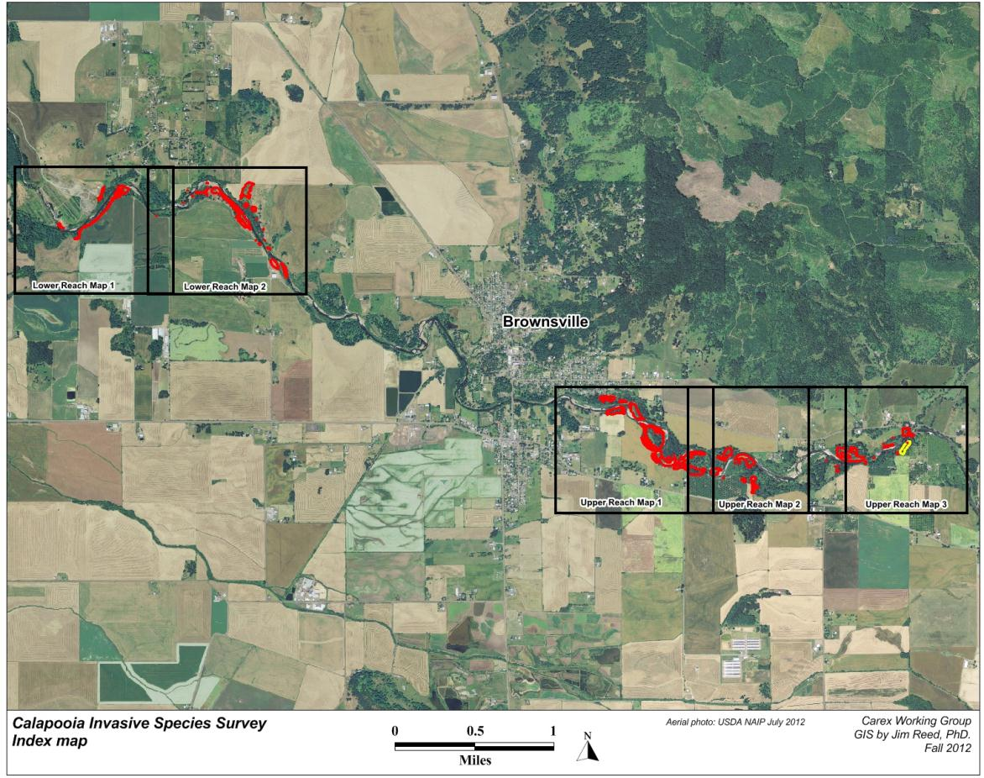
Figure 3a. Weed map. Lower reach, lower portion.

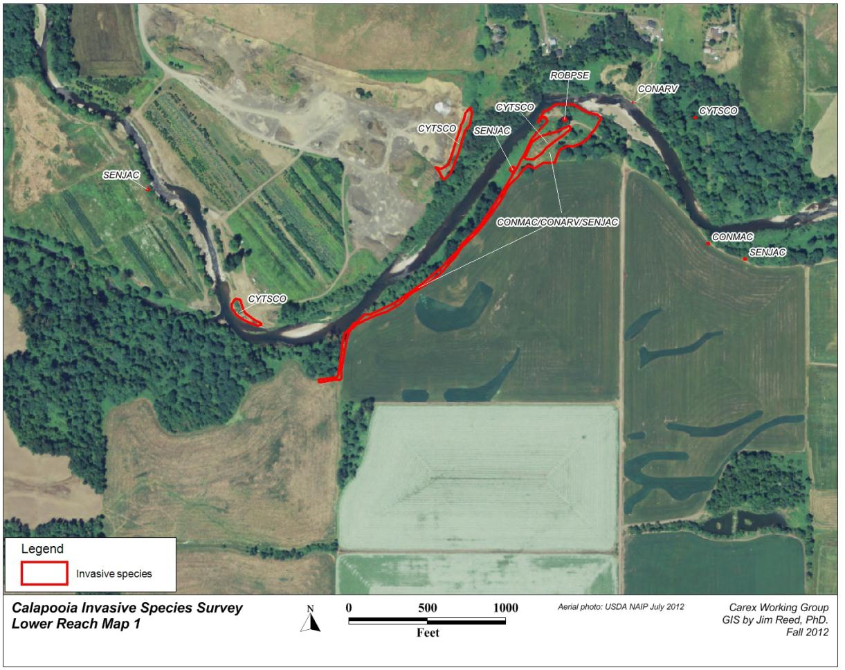
Figure 3b. Weed map. Lower reach, upper portion.

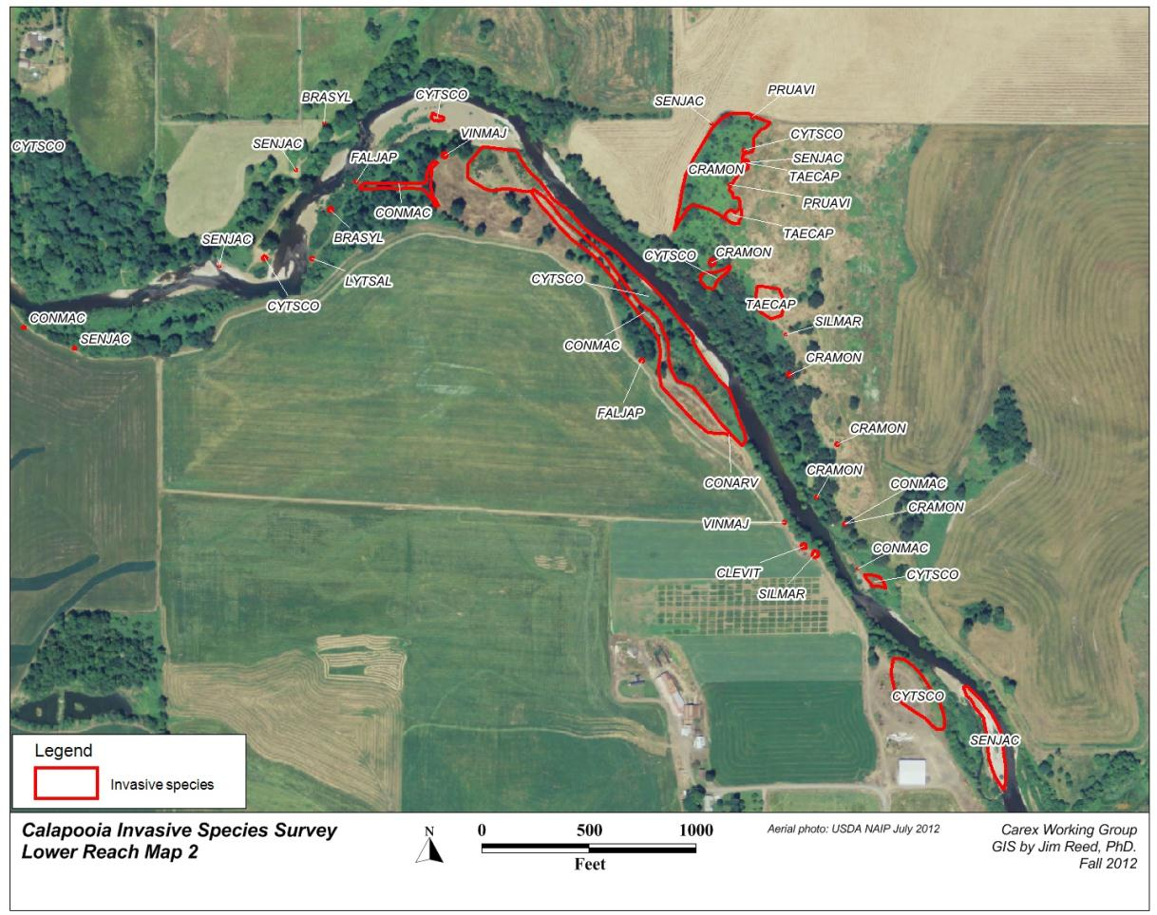
Figure 3c. Weed map. Upper reach, lower portion.

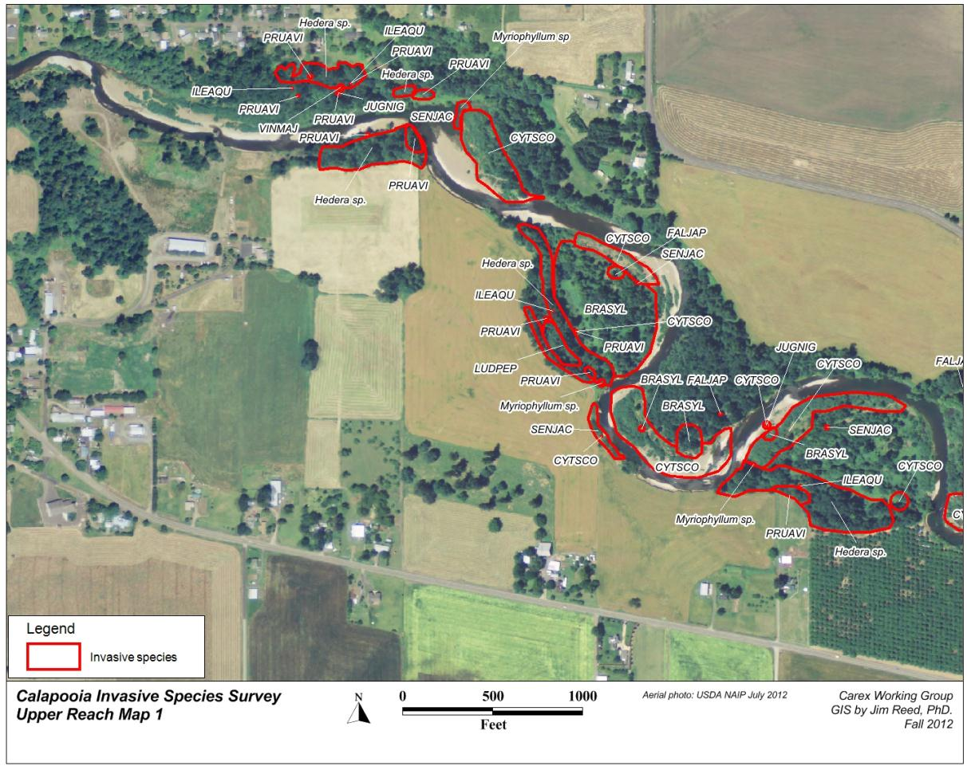
Figure 3d. Weed map. Upper reach, middle portion.

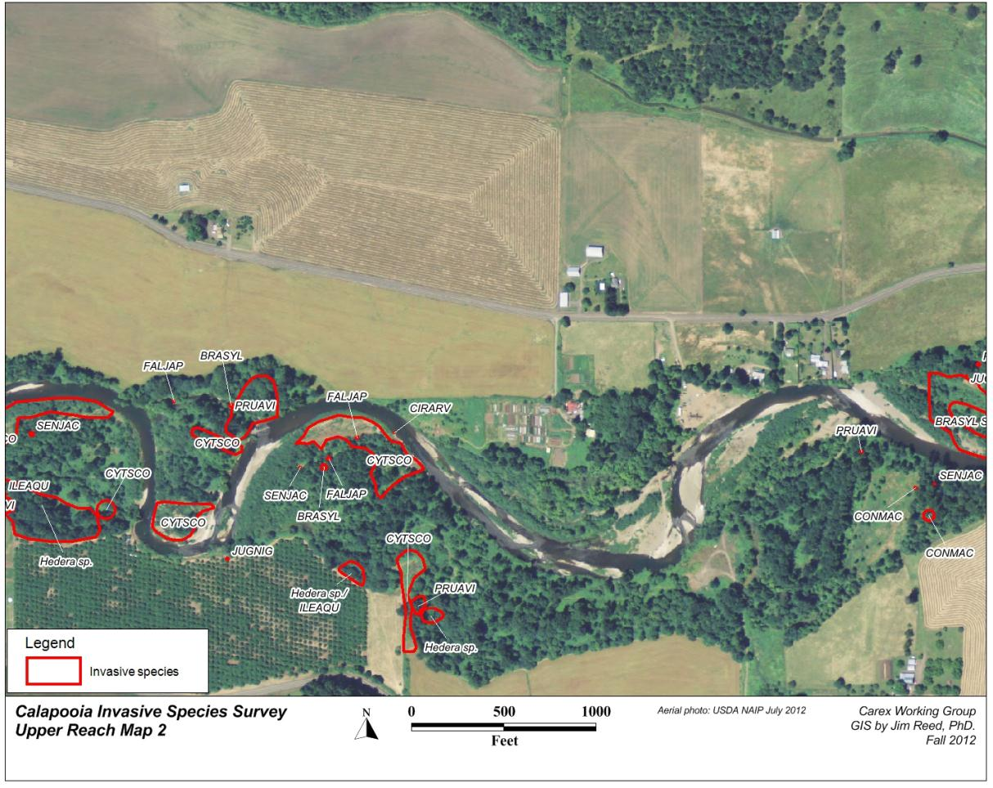
Figure 3e. Weed map. Upper reach, upper portion.

